SPECIFICATIONS

Name / Type: | SINGLE PLATE | TRIPLE PLATE for frame | TRIPLE PLATE for frame
Granite | 180x90X1.9cm | 180X90 | 220X100
Grey/ Black | One piece packed | EACH PIECE IS: | EACH PIECE IS:
 |  | 54.9x90x1.6cm | 68x100x1.9cm
 |  | Three pieces packed | Three pieces packed
FOB price |  | together = SET | together = SET
IMPORTANT: Size accuracy for triple plates is +/- 0.5 mm tolerance for thickness and width.
For single plates accuracy is +/- 1 mm. Not more, not less.
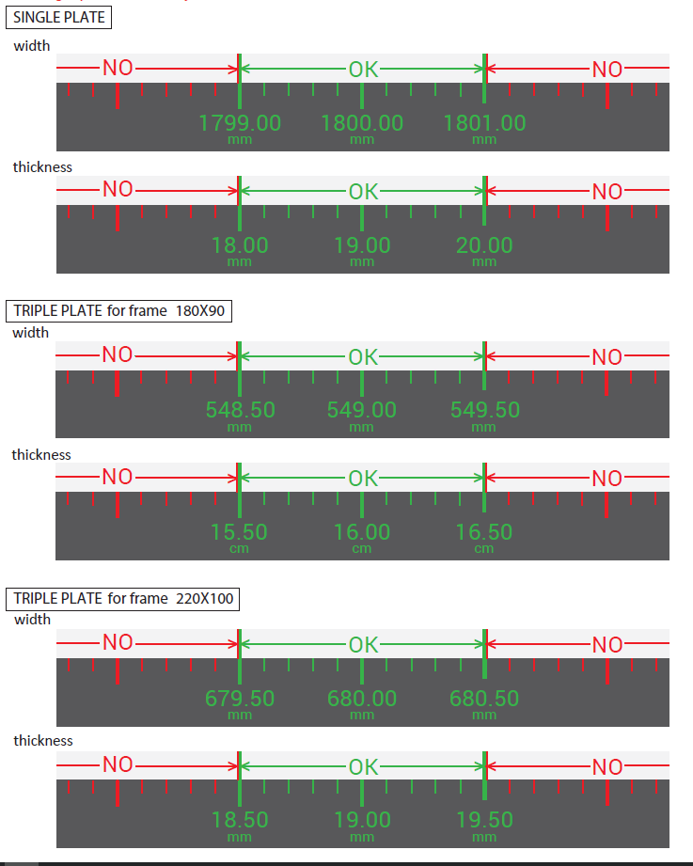

FURTHER DESCRIPTION

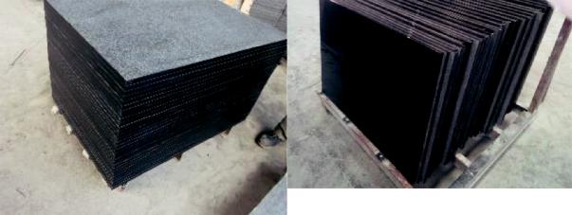
Black polished granite. Most preferably competitive in price granite stone with clean surface.

Gray polished granite: Fujian gray stone G654 without big grain, stains, dots, marks. For single plate 3 dots not bigger than 1 cent coin are allowed, for small plates only 1 stain in this size. Dots can’t be very dark or diﬀerent color.
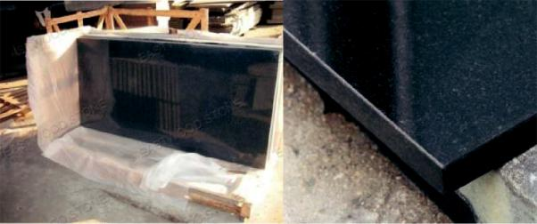
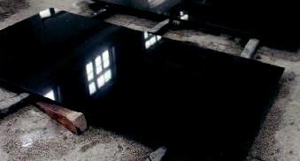

Single plate= 1 piece= 1 table top

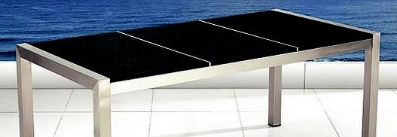
Triple plate = 3 pieces = table top. Measures and appearance of three pieces of one table top must be identical so they make good set together.

Treatment: very important

Polished stone: cut to size, top + edges polished, 1mm edge finish (chamfer) for all edges –top and bottom. Oil type waterproof treatment. 5 sides sealed.

Flamed stone: cut to size, top amed and brushed 3 times, all edges polished 1mm edge finish (chamfer) for all edges - top and bottom. Oil type waterproof treatment in shinny finish, not mat. 5 sides sealed
Stones will be used as table tops for outdoor furniture. Size of triple plate needs to be very precise to fit the steel table frame. Finish also very precise and detailed (edges, polish etc.). No stains, cracks, marks allowed. Stone must be one color only without any color discrepancies. Waterproof treatment must be applied on flat surface. Stones must be dried and cleaned before packing. All stains and smears from waterproof treatment will be considered as manufacturing damage and rejected.

SIZES

 | 1. FOR TRIPPLE |  |  |  |  | 2. FOR TRIPPLE |  |  |  | 3. FOR SINGLE PLATE
 | PLATE |  |  |  |  | PLATE |  |  |  | (180x90 cm)
 | (frame 180 cm) |  |  |  |  | (frame 220 cm)
 |  |  |  |  |  |  |  |  |  | 1PC IN SIZE: |  | 1.9 cm
 |  |  |  |  |  | 3PCS IN EQUAL
 | 3PCS IN EQUAL |  |  |  |  | SIZES: |  | 1.9 cm
 | SIZES: |  |  |  | 1.6 cm
90 cm |  |  |  |  | 100 cm |  |  |  | 180 cm
 |  |  |  |  |  |  | 68 cm |  |  |  | 90 cm
 |  |  | 54.9 cm
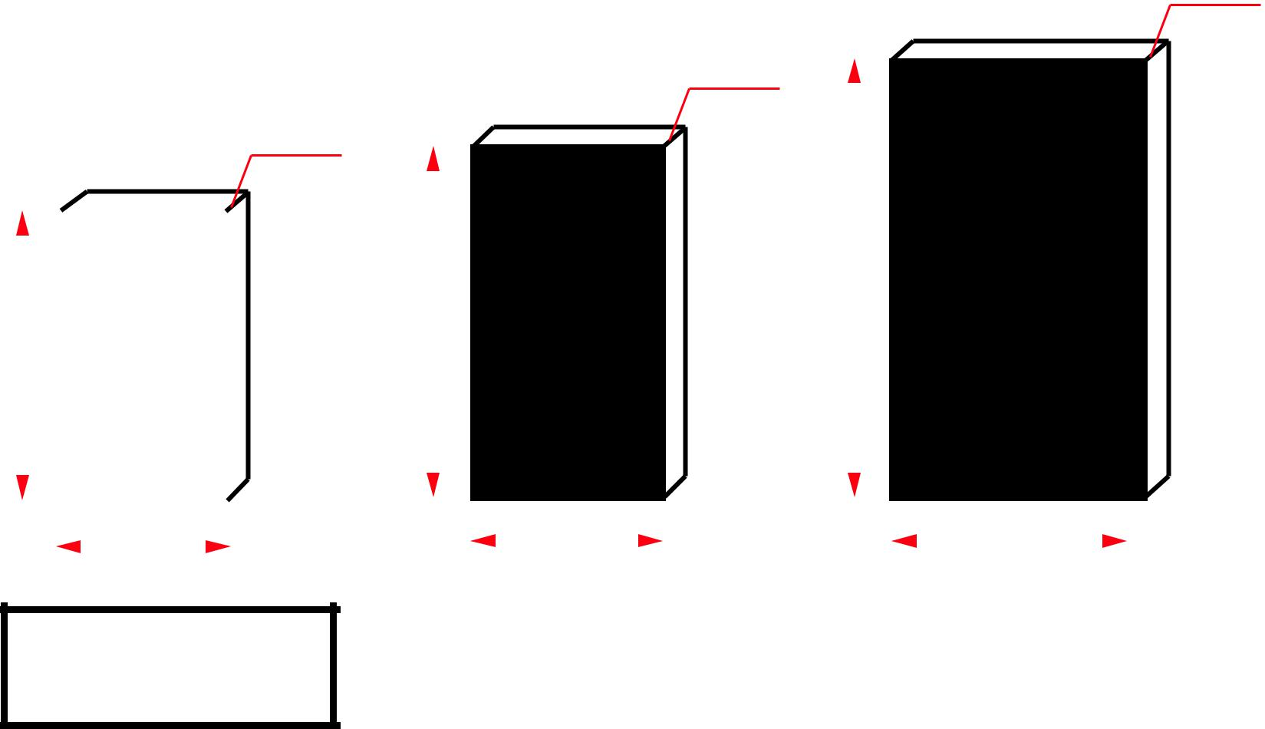

FINISH CORNER & EDGES

TOP EDGE 1mm FINISH
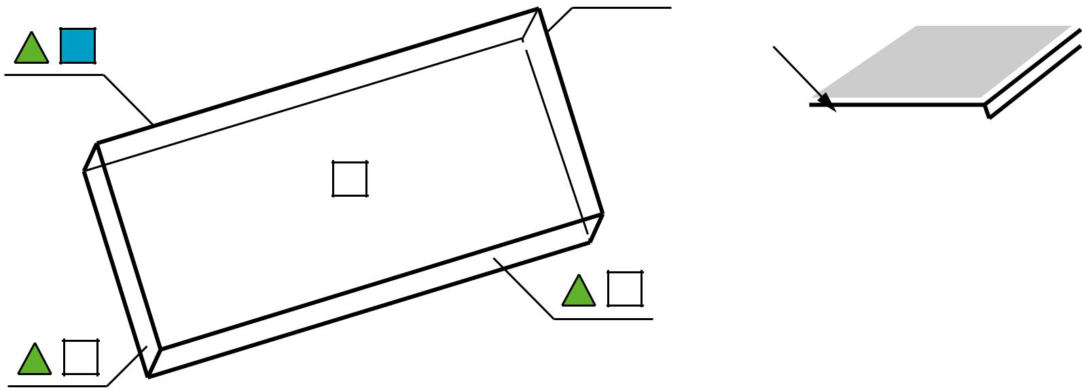
EDGE FINISH

 |  |  |  |  |  |  |  |  |  | ALL CORNERS
 |  |  |  |  |  |  | BOTTOM EDGE |  |  |  |  | POLISHED
 |  |  |  |  |  |  | 1mm FINISH
 |  |  |  |  |  |  | ALL SIDES
 |  | ALL EDGES POLISHED |  |  |  |  | TOP AND BOTTOM EDGES
 |  |  |  |  |  |  | CHAMFERED AND POLISHED
 |  | WATERPROOF TREATMENT
 |  |  |  |  |  |  | 1mm FINISH
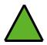
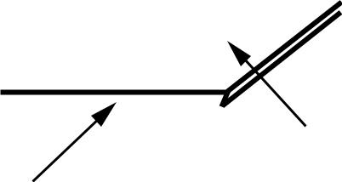

PACKING DESCRIPTION

As shown in pictures below. Container must be loaded ground + one level - on the floor and on first level TWO LEVEL STACKING ALLOWED- no more.

Container must be fumigated with heat and accompanied by certificate.

- FOR SINGLE PLATE (180x90 cm) = one piece in one wooden crate
Step one | Step two | Step three | Step four | Step five
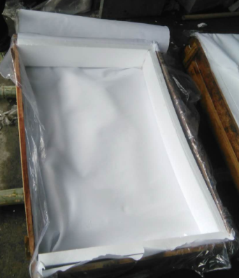 | 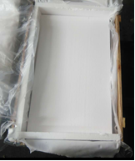 | 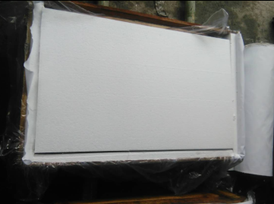  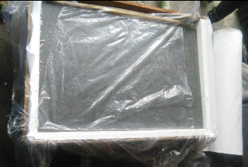 | 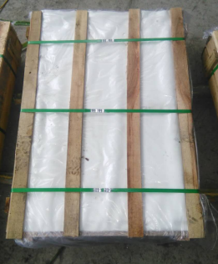 | 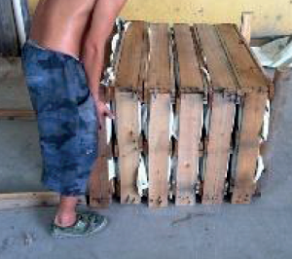
Fumigated wooden crate. Thick wrap. | Put on the bottom of crate 4 cm STYROFOAM (minimally 12kg/m³ ) plus 4 cm PU foam. | use foil to separate stone from Styrofoam (prevents scratches) place stone and  4 cm PU layer and  4 cm Styrofoam. | Single plate  Packed – add more slats | Max. 6 plates together in one master bundle. Put shipping marks on each plate and bundle.
Cross section view:
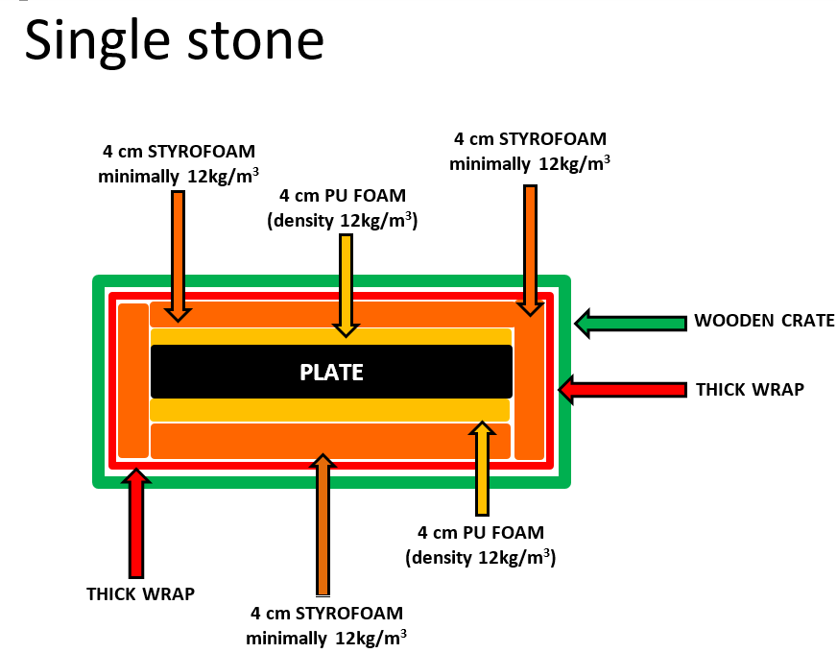

PLATE

2. FOR TRIPLE PLATE (180x90 cm) = three small pieces together in one wooden crate. EQUAL SIZES OF TREE PLATES OF THE SAME STONE

PACKED TOGETHER

Step one | Step two | Step three | Step four
 | 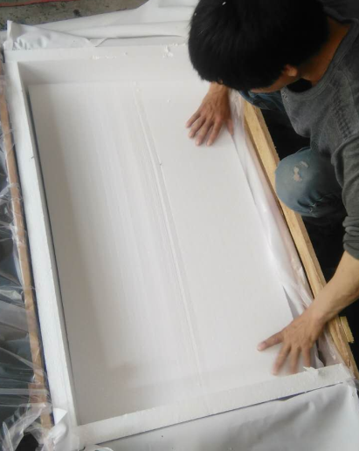 |  | 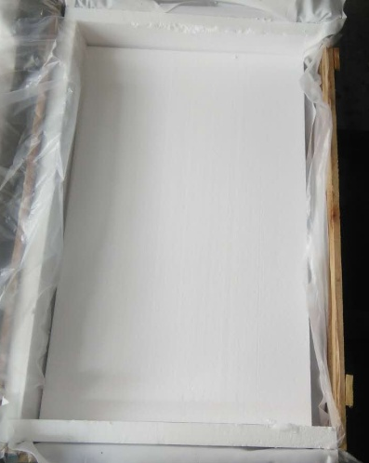
Fumigated wooden crate.  Thick wrap. | Put cardboard od bottom plus 4 cm STYROFOAM (minimally 12kg/m³ ) on it and around – use foil to separate stone from Styrofoam ( prevents scratches) | Place first stone plate inside and foil on top. . | Put 2 cm Styrofoam and foil on top (not shown on picture).
Step five | Step six | Step seven | Step eight and nine
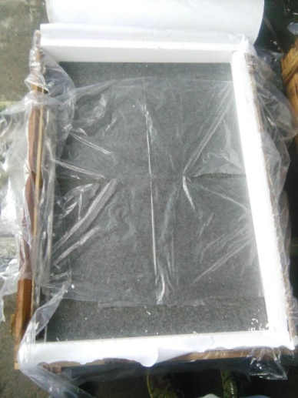 | 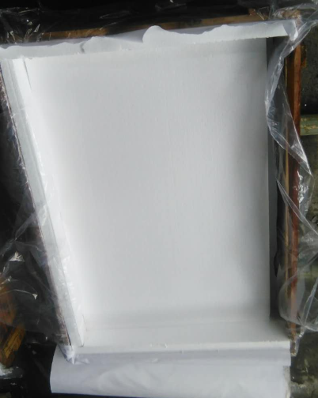 | 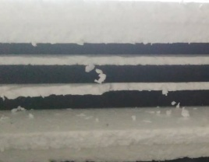  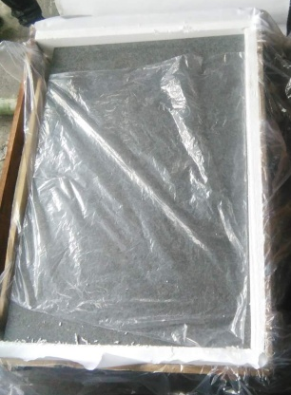  cross section view | 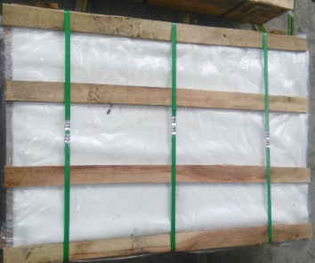  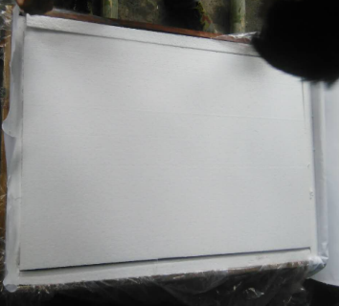
Place second stone. Put foil on second stone. | Place another 2 cm Styrofoam and foil on top. | Place third stone plate and foil on top.. | Finish with last 4 cm Styrofoam and cardboard. Secure bundle.

Cross section view

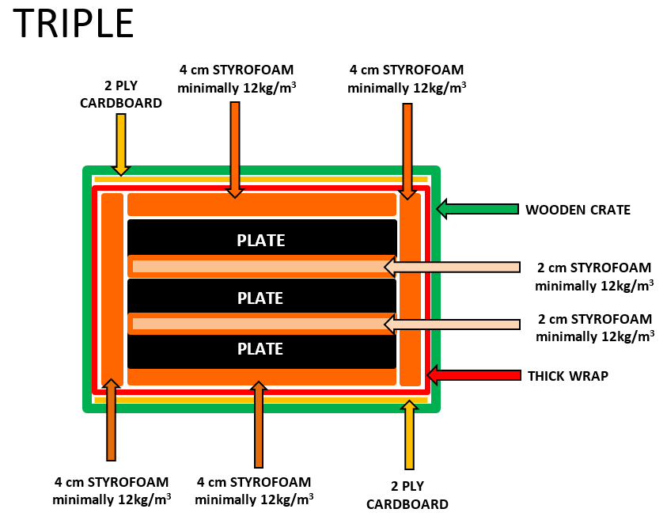

After preparing bundles each bundle must be marked with proper shipping mark please see example below:
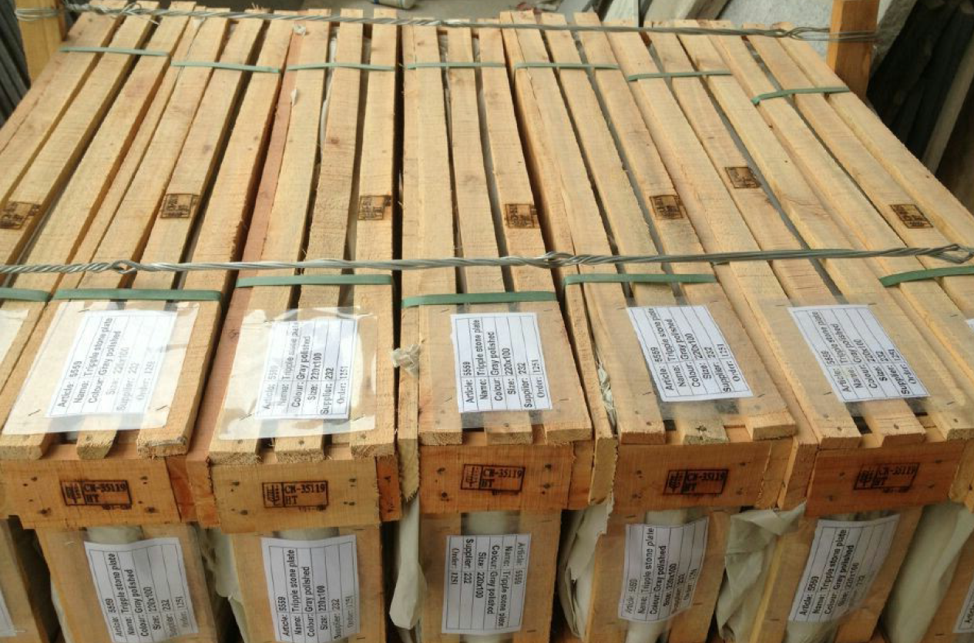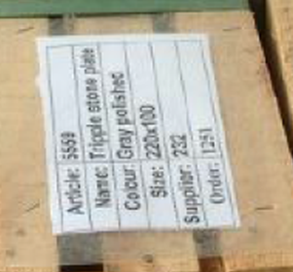

IMPORTANT

After loading container supplier must send via email:

- pictures of loaded container – crates must be secured!
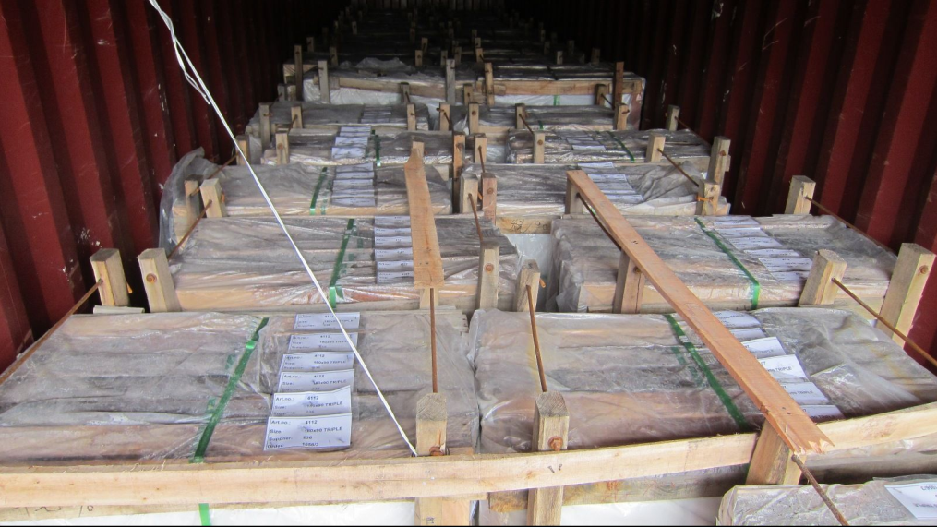
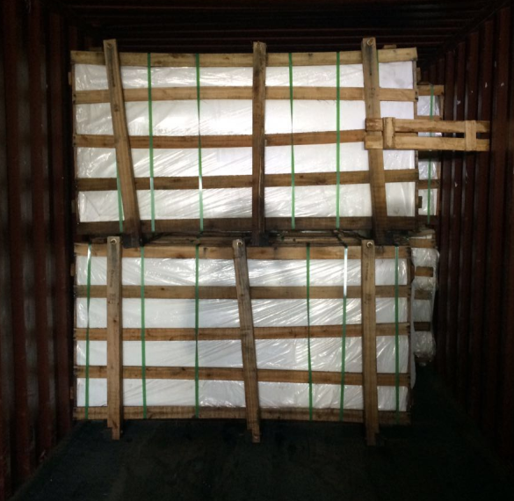
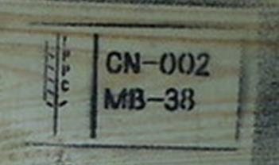
- pictures of fumigation stamps on wood

- fumigation certificate in English
- pictures of bundles with visible shipping marks
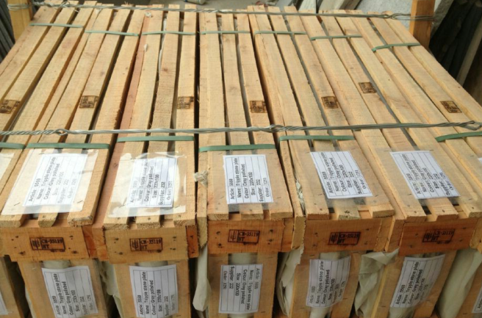

- container content table

- Other documents required by logistic department.

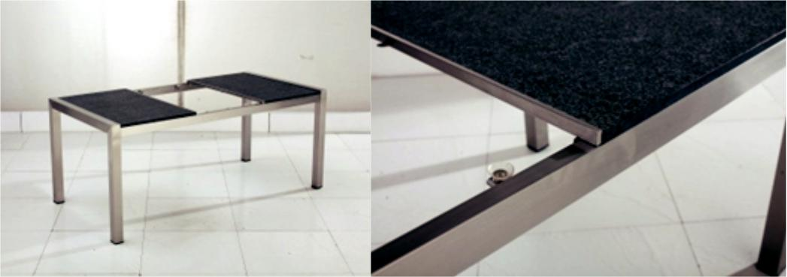

I CONFIRM, THAT I UNDERSTAND ALL REQUIREMENTS ABOVE.

PRICES INCLUDED ALL REQUIREMENTS ABOUT FINISH,

PACKING AND LOADING.

.............................................................

.............................................................

(sign and company stamp)

